#1 For all 3 services, button should say Place Quote
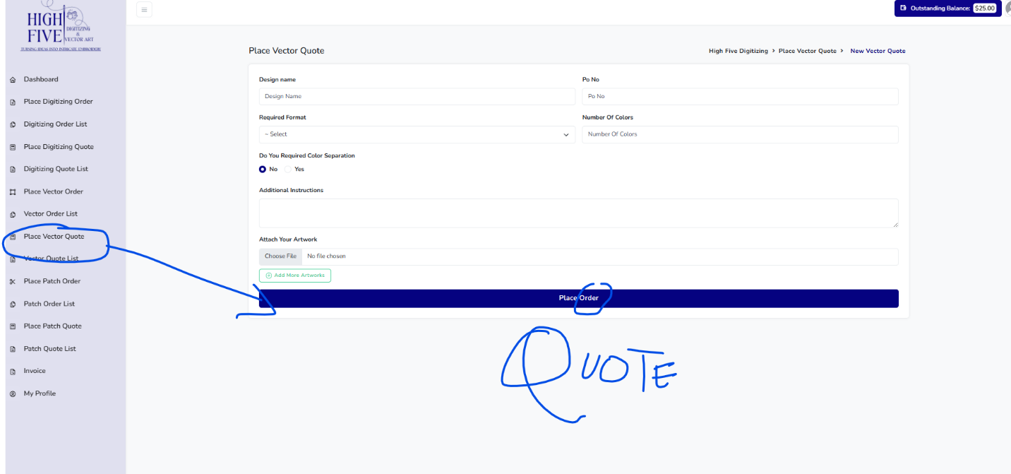

#2 keep color theme same as other forms.. dont like this dark green color
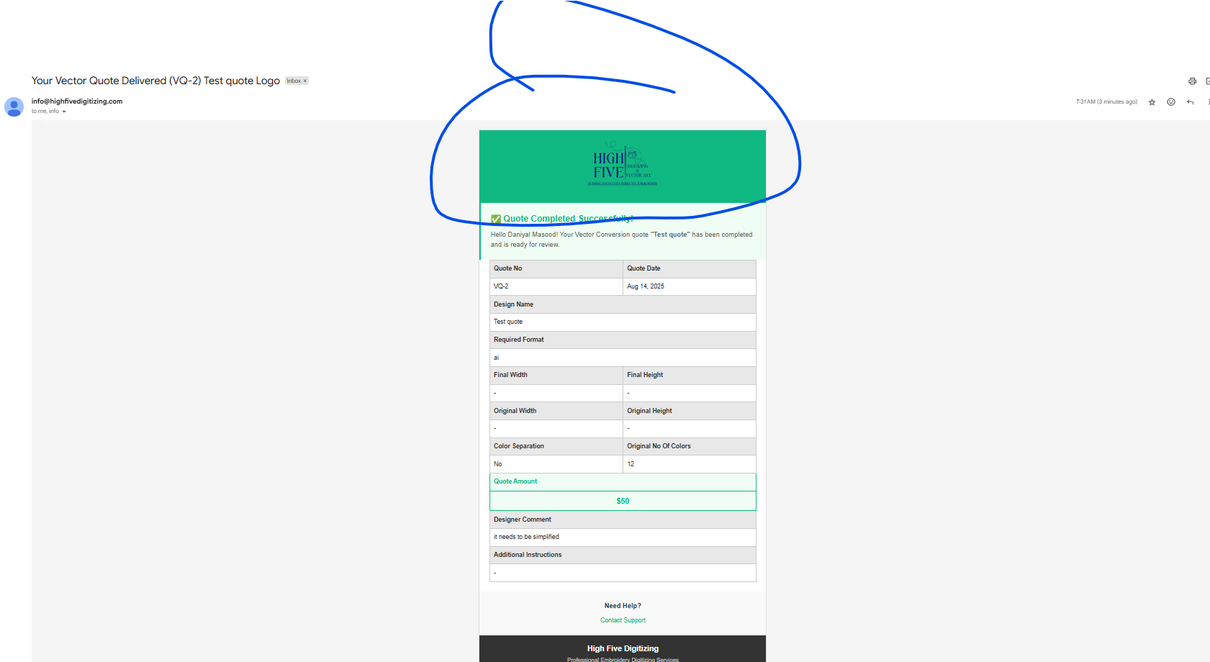

#3 Make logo bigger on invoice
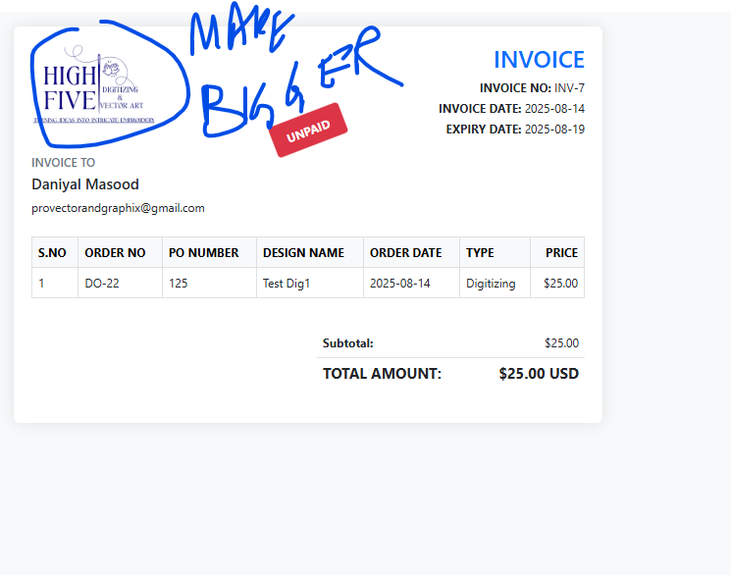
#4 Mention customer name and fix the sentence below. and missing company logo at the top.
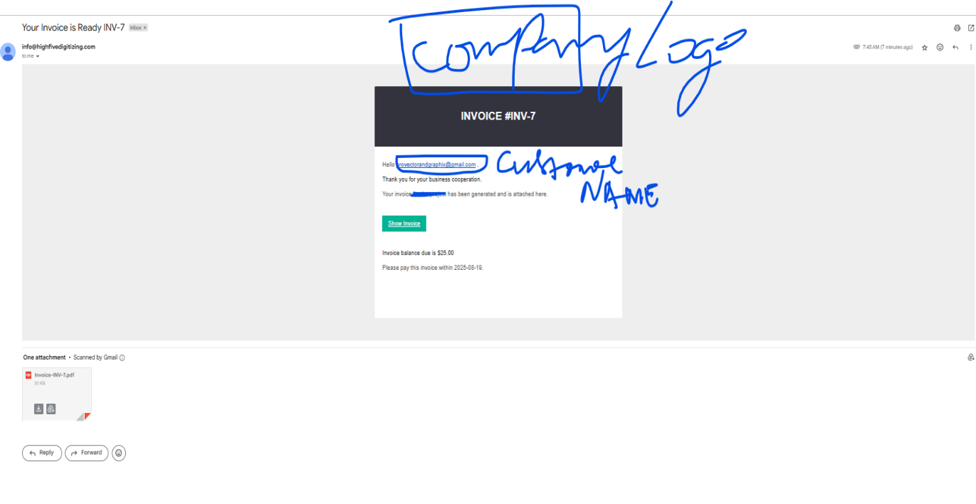
#5 Missing convert to order Button for Digitizing quote and patch quote
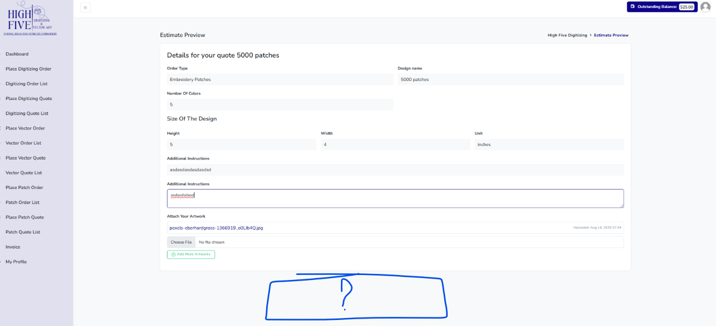

#6 Missing PES format on the form when customer is submitting digitizing quote or order
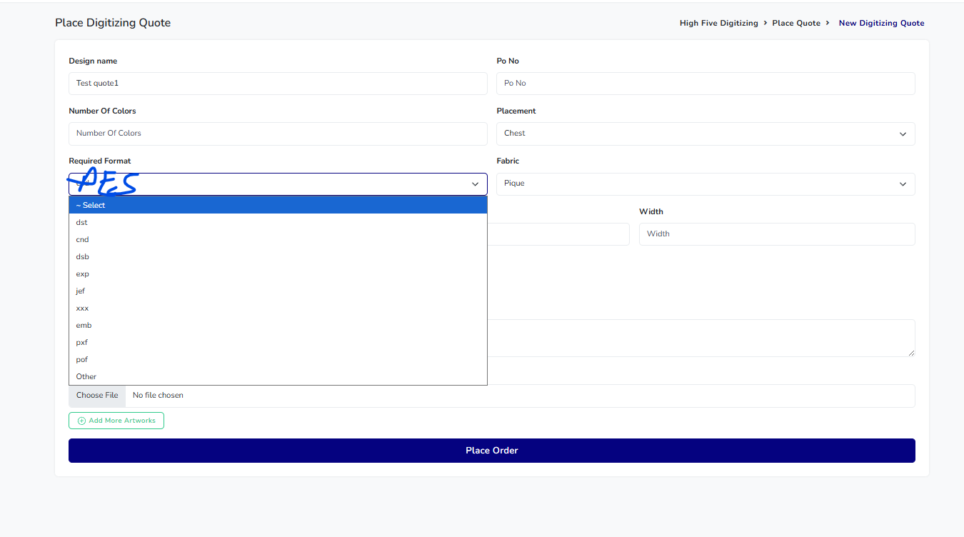

#7 (Final height and width) Not needed for vector quote or order. Because when we deliver vector quote or vector order we don’t mention dimensions (Height or width)… agr customer dalay place krte hue to show hojaye height and width bhi sirf usi case mn jab Color separations select krta hai wo.
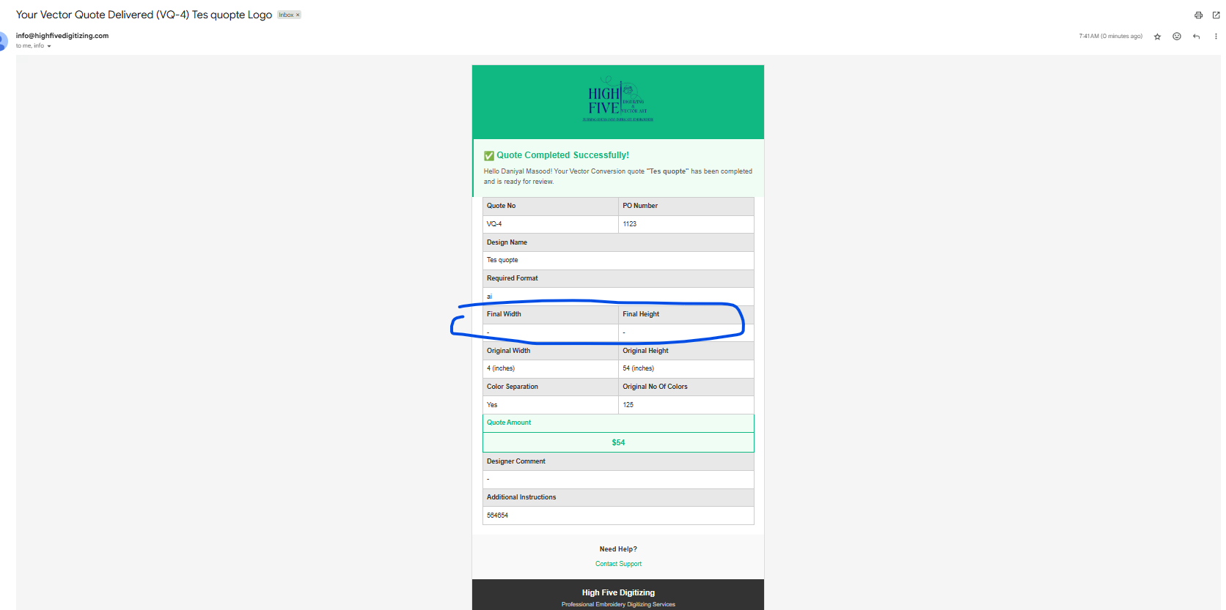

#8 Price should be $0 or not mentioned when edit is delivered
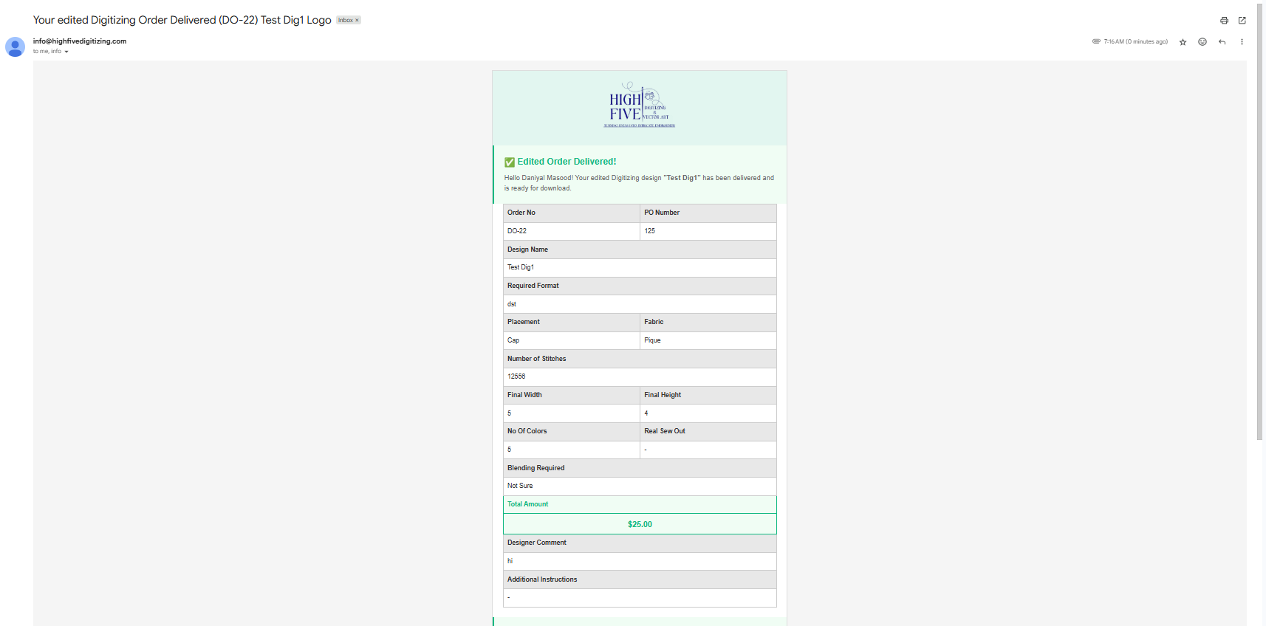

#9 Reduce the size for search bar and highlight with light purple theme color
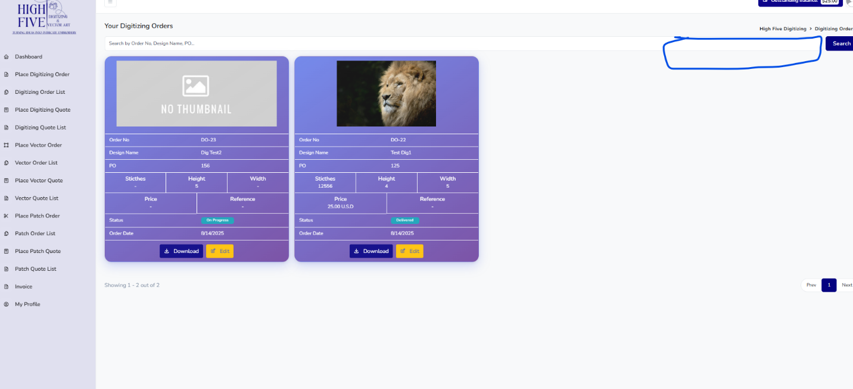

#10 When adding orders from Admin panel... Email is not received on customer email address. 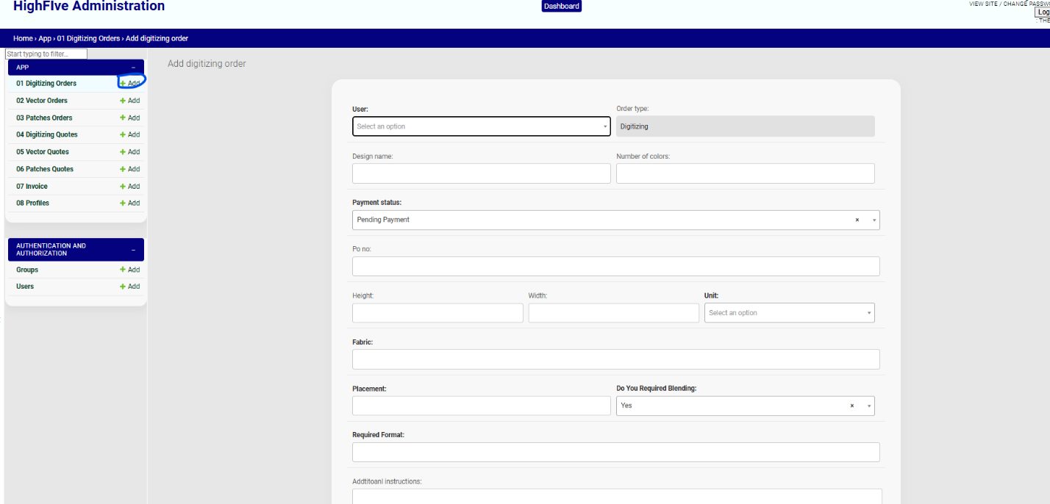

#11 when converting quote to order...”convert to order” button is missing
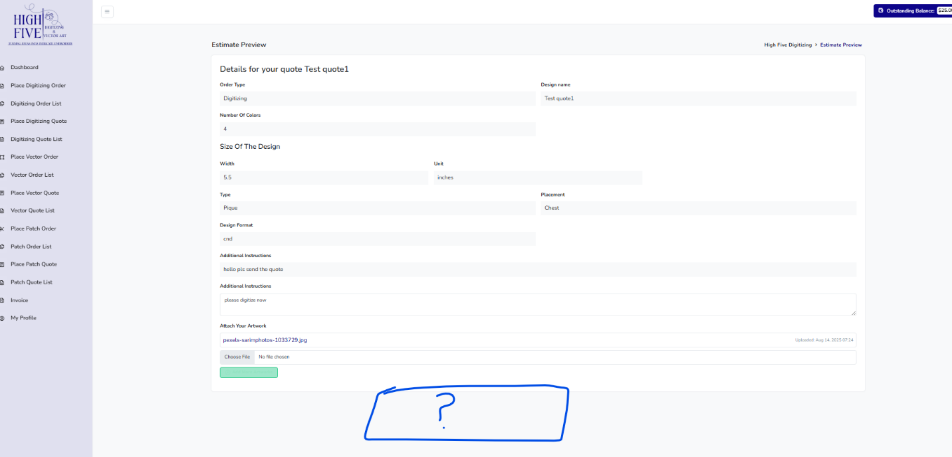

#12 when converting vector Quote to order showing this error
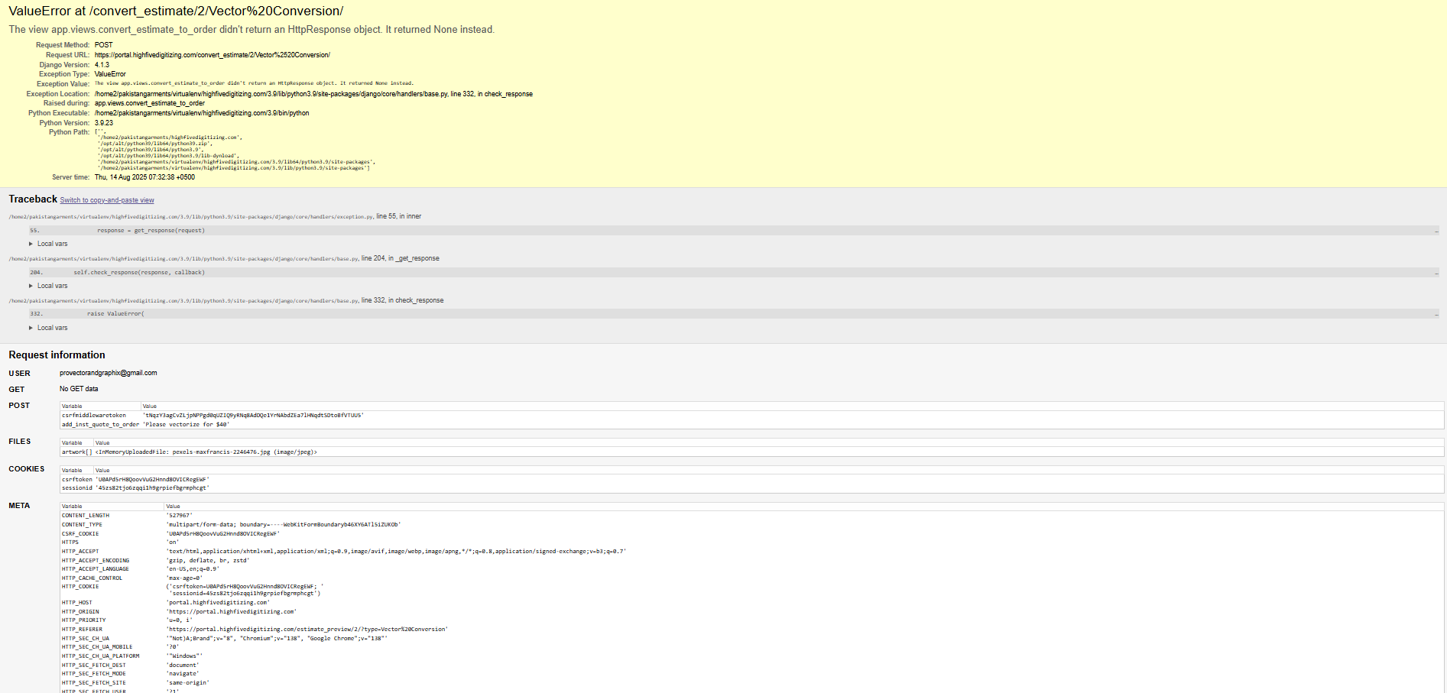

#14
*Make Logo Bigger on all forms as discussed
* Real sew out field was already removed, remove as discussed
*Do a partition and place the amount in dollars next to “Total Amount”
* Remove green highlight from the Amount field

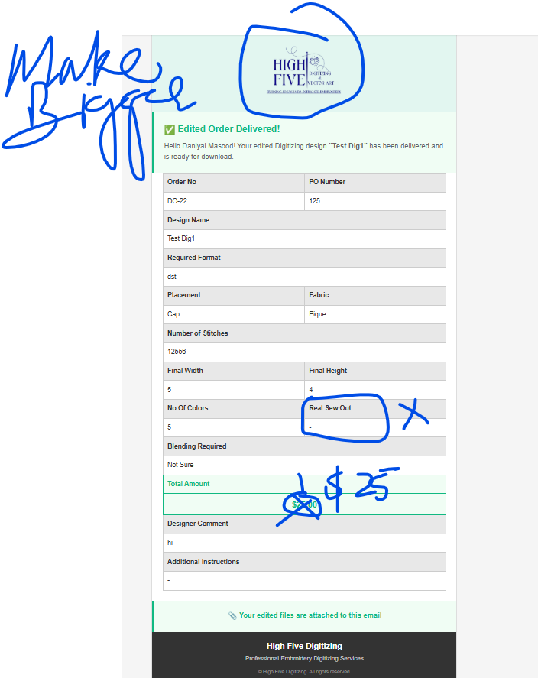

#14 When viewing invoice from Admin panel or customer account. These errors appear

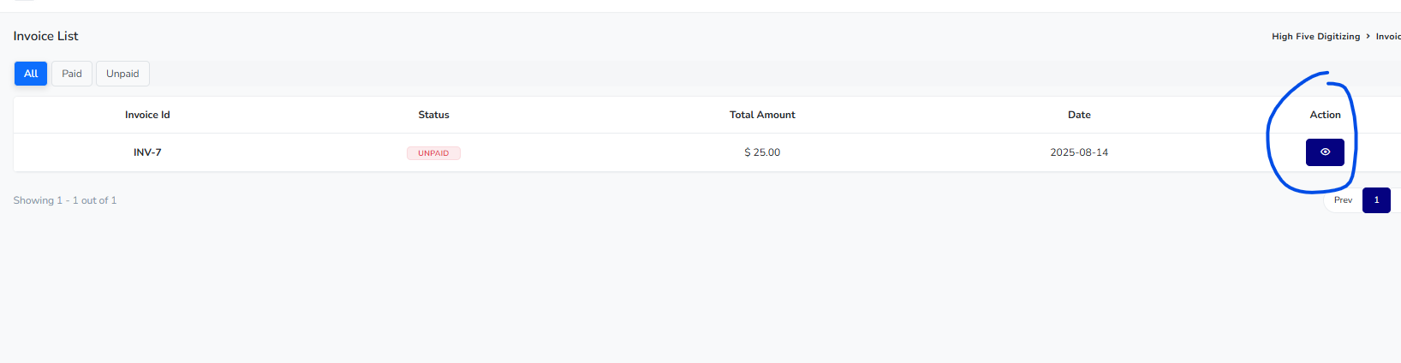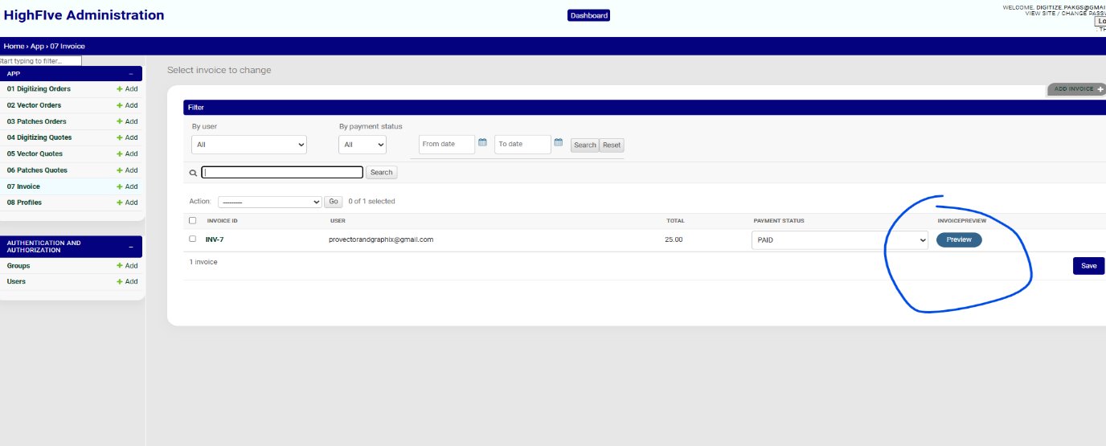
These errors appear
